Telescope

Subject: Physics, Light,Reflection,Optics  Related Subjects: | Grade Level(s):  Length of Lesson: | Type: Inquiry / Design / Project  Keywords:Astronomy, measurement, focusing

Lesson Overview

Telescopes have been around for centuries. Famous scientist like Galileo, Copernicus, Democritus, Kepler and many others used them to study the stars.

Lesson Focus
Students will use magnifying glasses and pvc pipes to create refracting telescopes.
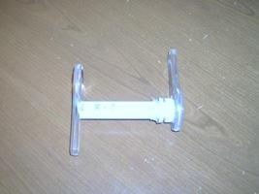

Lesson Objective(s) | By the end of this lesson, students will…  - create a refractor telescope using magnifying lenses

Lesson Timing

5 minutes | Introduce the Lesson
30 minutes | ...

Materials | - 2 magnifying glasses  - PVC  - Saw  - Glue Gun  - Glue Sticks  - Water or soda bottle  - Ruler  - Flashlight
Instructor Prep | - Step 1
Related Resources | - List related lessons/ppts etc available from USC or outside, trusted orgs

Lesson Plan

Introduction
Introduce students to the learning goals and make connections to past and present learning experiences. Stimulate interest and prompt students to identify their own questions about the topic. This can link the lesson to real world examples, introduce associated STEM careers, and assess their prior knowledge on the topic.

- Step 1

Procedure
List the steps of the activity. Remember to focus on leading students to the solution, rather than just telling them what to do. Include pictures of steps if you have them. Be sure to include some steps for discussion and reflection.

- Hold a flashlight about 10ft away from a wall.
- Using one of the magnifying glasses, focus the beam on the wall.
- Using a ruler, measure the distance from the magnifying glass to the wall. This is the “focal length” of a magnifying glass at infinity. For the standard (40mm diameter) magnifying glass this should be about 80mm
- Examine a sheet of paper with typed words on a flat table with the other magnifying glass. Move the glass away from the words until the words are as large as they can be without being blurry.
- Using a ruler, measure the distance from the magnifying glass to the table. This is the other focal length of the magnifying glass. For the standard (40mm diameter) magnifying glass this should be about 32mm.
- Remember, the first lens of a telescope focuses an image from far away to a focal point, and the second lens enlarges that image at its focal point.
- Add the two lengths together to get the length of the telescope tube. In our case 112mm.
- Cut the pvc pipe to that length.
- Unscrew the cap from the rim of water bottle and cut a hole in cap
- Cut the top rim off of a water bottle.

- Insert the pvc into the remaining rim of the water bottle until the end of the pvc is flush with the top of the rim and then glue into place
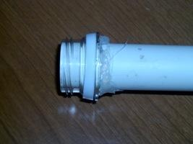

- Glue the back of the cap of the bottle to the center of one magnifying glass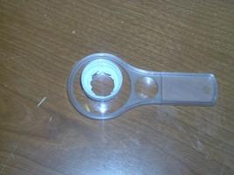
- Glue the other end of the pvc to the center of the other magnifying glass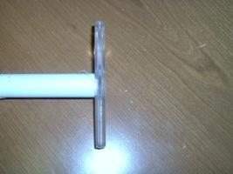
- Screw the magnifying glass and cap on to the pvc

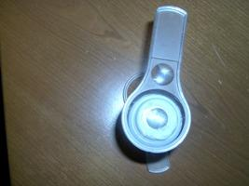

Wrap-up
End the lesson with some final discussions about what students designed/discovered. Connect their activity back to the focus question/problem, real world examples, and STEM careers.

Also include notes about any special cleanup considerations

Lesson Background for Teachers

Suggested Real-World STEM Connections
- List possible related Role Models in STEM (with details and links to more reading). Give suggestions for examples of scientists/engineers who are from underrepresented groups in STEM in related careers.
- List related real-world engineering problems and examples

Lesson Variations and Options
Include descriptions of alternative methods or ways to present things.

Explanation
Describe the background concepts and explanations behind the lesson. This can be more in depth than a teacher/instructor would actually share with students.

Key Concepts and Vocabulary
- Word 1: Grade Appropriate Definition
- Word 2: Grade Appropriate Definition

Safety Notes
- Safety instruction

